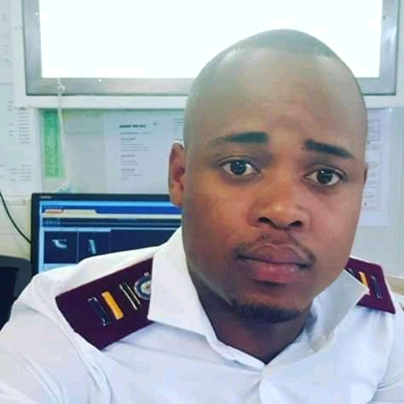 |  | asIVE XASO
Career objective:  Dedicated and motivated individual looking to secure a challenging professional nurse position at a reputable Hospital to apply and expand my knowledge and skills whilst contributing significantly to the success of the Health institution. Being the focused, driven, self-starter that I am, I believe I will be a great asset to any institution.  +27 83 285 9782  ADDRESS:  No.5 Robison Street  Butterworth  4960  3453765@myuwc.ac.za  3453765@gmail.com  References  Sr Claudine Jefthas  Unit Manager (Oncology unit)  Red Cross Children Hospital  072 340 2021  Sr S. Swarts  Trauma Unit Operational Manger  Red Cross Children Hospital  0732149709  Rn Bonani Xakekile  Unit Manger( Renal Unit)  National Renal Care  0831178851 |  | University of the Western Cape (UWC)  Febuary 2014-December 2017  Bachelor of Nursing (Hons)  Gobe Commercial High School  November 2013  Senior certificate  Achievements: Received numerous leadership awards in high school and in my undergraduate studies.  Profesional Nurse- National Renal Care  September 2021  - Primed dialyzer and bloodlines recording patients’ medical information and vital signs  - Partcipating in Dr’s rounds and executing orders.  - Advocating for patient care during rounds by reporting symptoms  - Covid screening of staff and patients upon entry at the facility.  - Oversaw dialysis treatment and cannulated accesses  - Administered medications including thrombolytics and anemia medication.  - Cleaned and dressed permanent and temporary catheters(hickman lines)  - Monitored patients adjusted specialized equipment and interpreted and recorded information  - Provided pre- and post procedure care to patients within the Hemodialysis Unit  - Giving health education on fluid management at home and giving educating patients about diet.  - Stock control management.  professional Nurse – Red Cross War Memorial Children Hospital  Feb 2019 –April 2021  - Record medical history and symptoms  - Taking bloods from arterial and central lines( Ports, Hickman's line and Cvp lines)  - Accessing and de accessing of ports and hickman lines using 10 mls of heparinised saline.  - Assisting Doctors when performing bone marrow aspiration and lumbar puncture and giving intrathecal chemotherapy.  - Caring for neutropenic, post transplants and isolated patients applying IPC principles  - Collaborate with teams to plan for patient care and follow Dr's ordrers  - Advocate for the health and wellbeing of patients  - Monitor patient health and record signs  - Administer medications and treatments(chemotherapy after hours and on weekends when there is no Oncology specialised Sister)  - Operate medical equipment  - Perform diagnostic tests  - Educate patients about management of illnesses  - Provide support and advice to patients  Professional Nurse - Red Cross War Memorial Children Hospital  Feb 2018 – Jan 2019  - Providing triage, diagnosis and care for trauma patients, and preventing secondary complications.  - Handling serious injuries and illnesses, such as car accidents, suicide attempts, and heart attacks.  - Preparing patients for emergency operations and assisting surgeons in the operation.  - Distributing emergency medications.  - Working with urgent care patients and traumatized family members.  - Managing a chaotic and stressful work schedule.  short courses  Haemophilia course  Basic life support  Occupational health course(Awaiting certificate)  Basic CPT course- UCT (completed Awaiting Certificate)  Skills  Strong work ethics  Problem-solving skills  Positive attitude  Excellent team player  Good communications skills – fluent in isiXhosa, English  Time management abilities  Working well under pressure  Flexibility/Adaptability  Patient Safety  Inpatient Care  Acute Care  Medical-Surgical

